**SIT 206 IOS Programming Assignment 2 project.**

Name – Kaluappu Hennedige Sachin Avishka de Silva

Student ID – 215326393

**Project title – Twitter Client**

**Project team – Kaluappu Hennedige Sachin Avishka De Silva (Name)**

**215326393 (Student ID)**

**Project description –**

This is a basic twitter client I made for users who wants to have multiple functionality within a single application. So this app comes with a built in twitter client where a user can search for a twitter account and read the tweets and also with a built in web browser. If in any case the user wants to check some information on web, he/she can simply head to web browser and search for that particular info. For this app I have used data from twitter API and I used table view and web view to present tweets and browser results respectively. If the user likes to share the content which is in the twitter feed, user can simply click the share button and share it on either Facebook or Twitter. Note that the user has to be signed in to the respective social media platform to post the content. The web browser too has three buttons which allows user to go back, go forward and refresh the webpage. This is basically what the idea of the application that I made.

**Project Features –**

Basic layout –

This image shows the main layout of the app after opening.

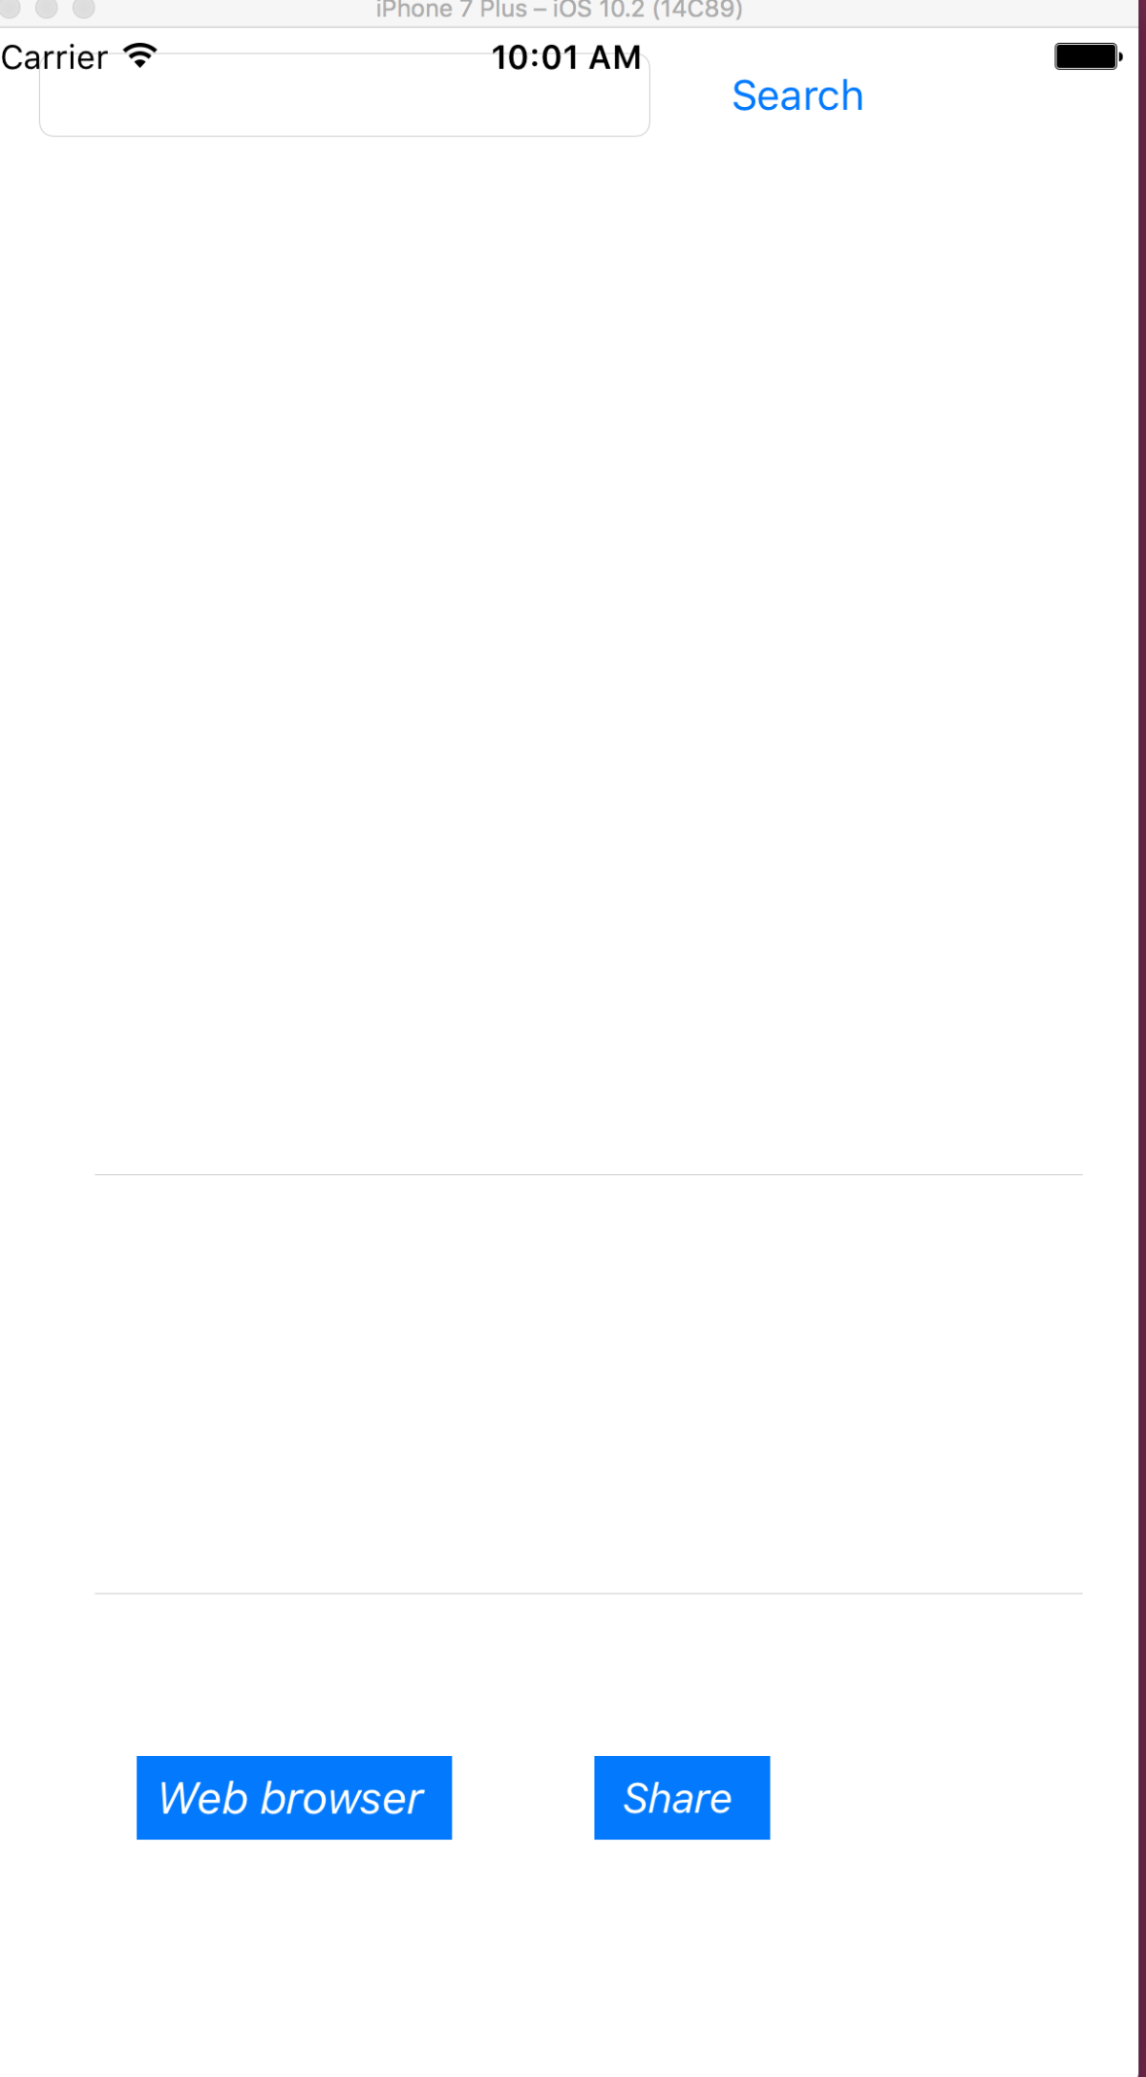

The following image shows the results when a user enters a specific twitter name. This is the first feature that I have implemented in my application.



The next feature I implemented is the integrated web browser. A user can search for anything just like using a normal web browser.

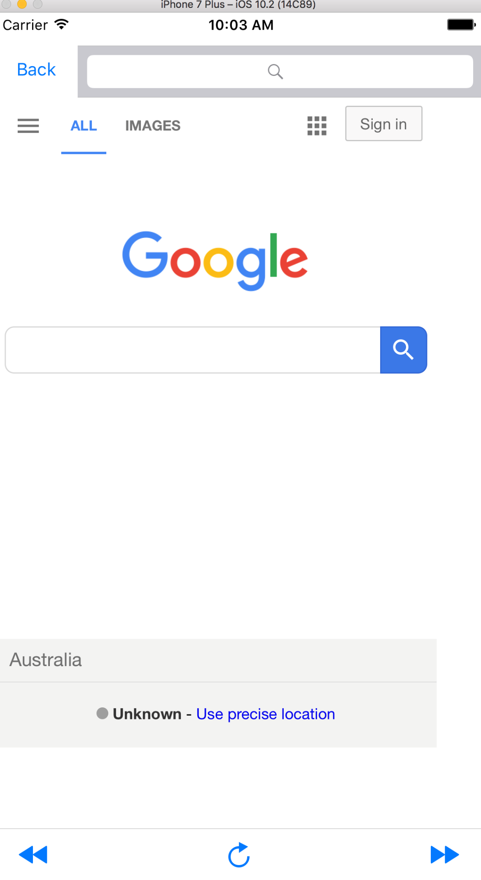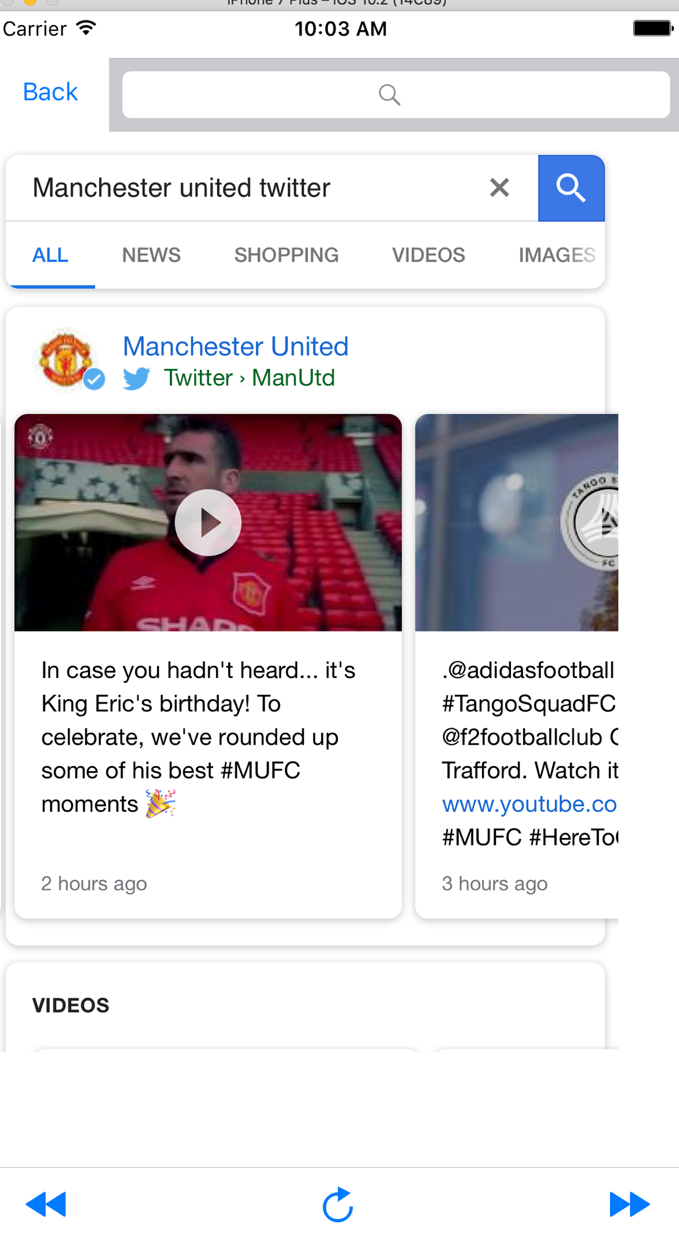

The third feature I added is to share the content on twitter or Facebook. The user can share it on either social media platform (User has to be signed in from the device in order to post the content). If the user is not signed in to the respective network, the app will send an error message.

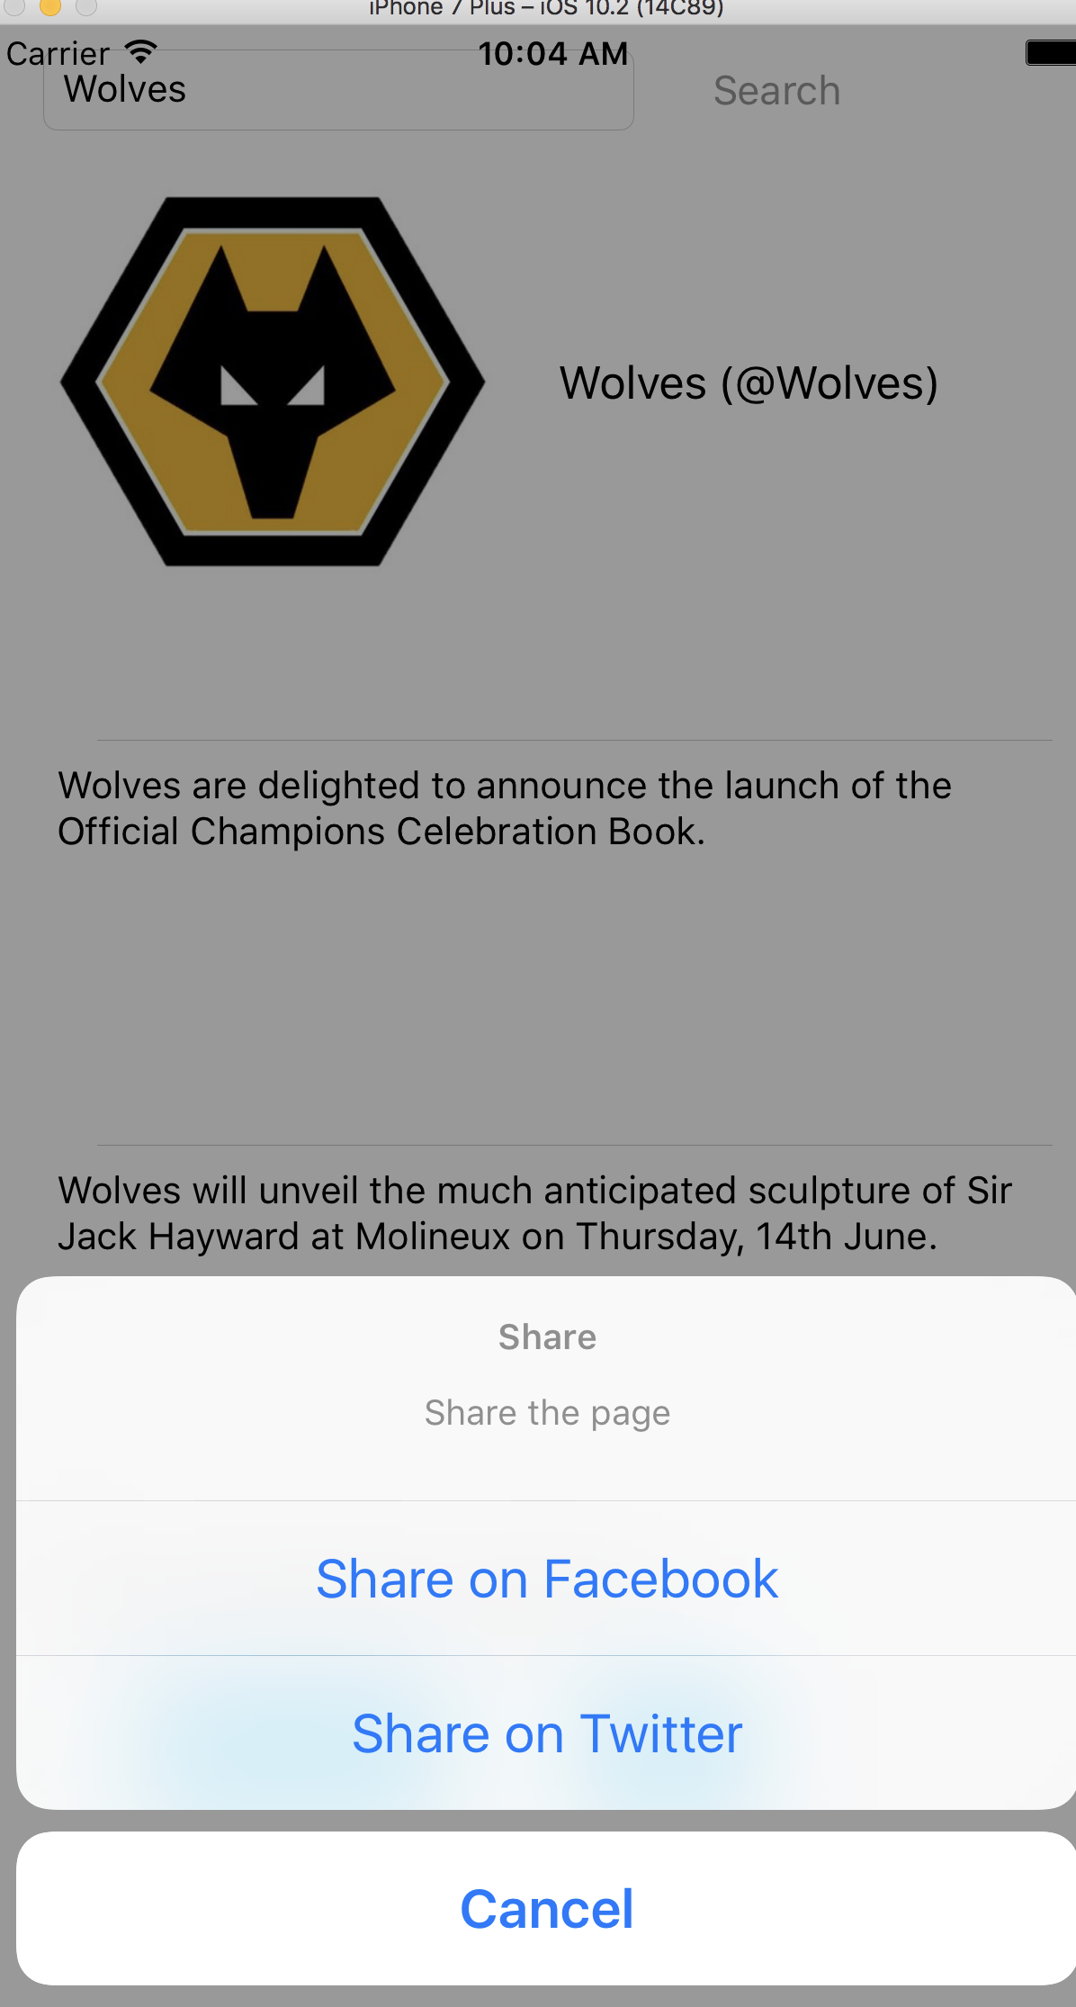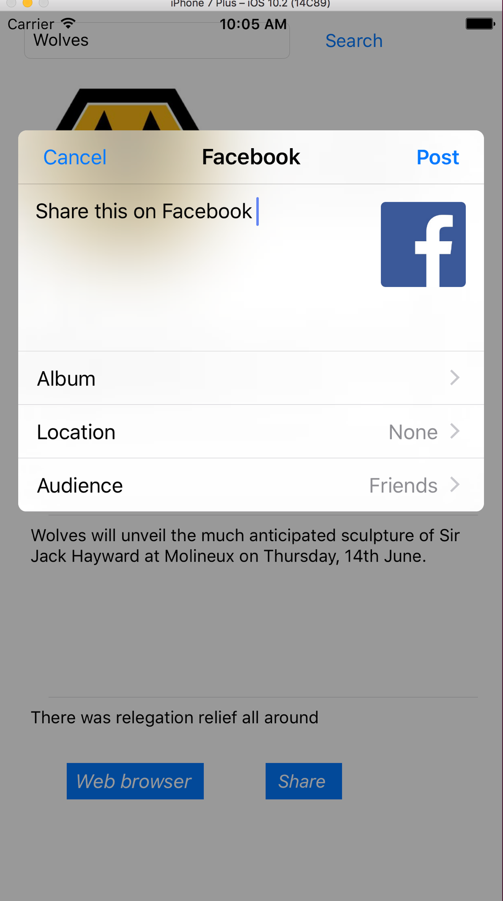**Class names and their functions summery**

**Class 1 name – View controller.Swift**

Functions –

This is where the twitter client and its functions take place. First the storyboard is being made in the main storyboard. After that the search (action) button adds the search twitter profile functionality.

The below screenshot shows the function where the app connects to twitter and gets all the data from twitter. After connecting to twitter, the app gets all the information from the twitter. It gets the name, profile picture and the tweets which has been posted by the account holder. If there are no users by the searched username, the program will show an error message. The code of that is given below.

This class also has the feature of sharing the viewing content on Facebook and twitter. First the user has to be signed up for posting things on social media. If the user is not connected, it will give an error message.

This class is also consisting of table view which I have used for displaying twitter results.

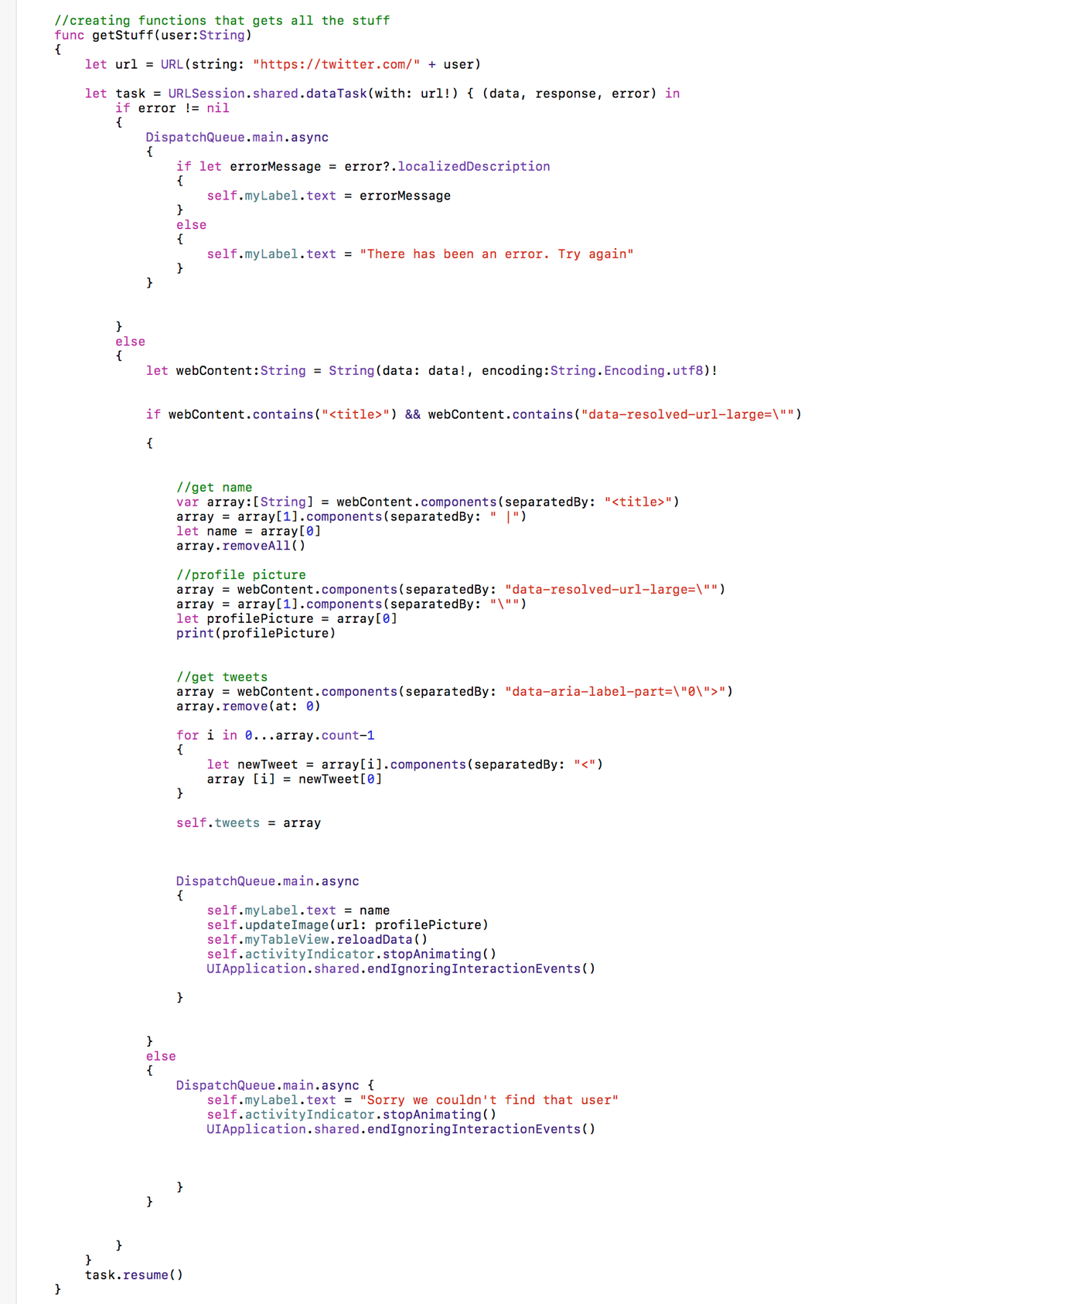

The code below gets the profile picture from the profile that the user searched for.

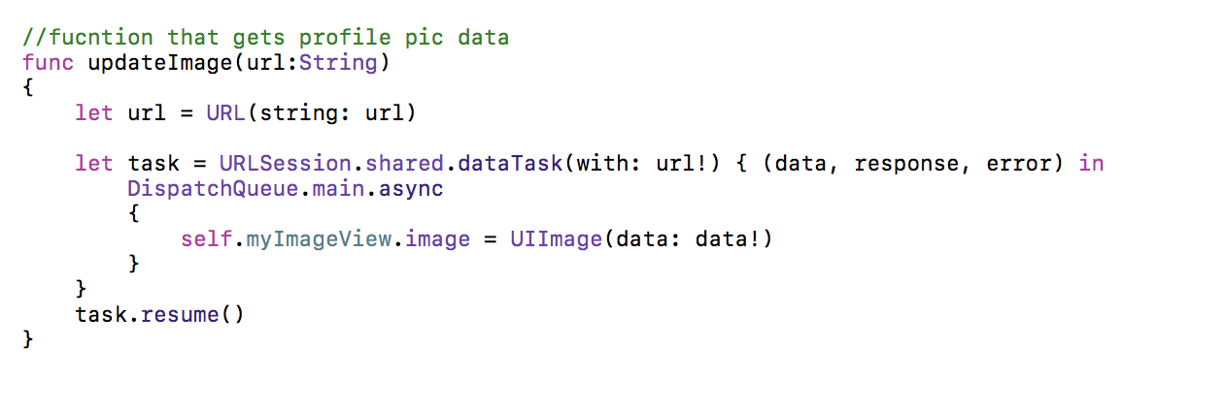

**Class 2 name – SecondViewController.Swift**

**Functions –**

This view controller handles the web browser function. The user can use the web browser like a normal person uses google everyday but this is integrated with the app and the user can use it anytime whenever the user using the twitter client without switching for another app to search web.

In this web browser, the user also gets the functionality to go back, go forward and reload the webpage. The search history will also be present on the search results. This is basically the functionality of this class.

The code for this class is given below.

